ST. XAVIER’S COLLEGE

**(Affiliated to Tribhuvan University)**

**Maitighar, Kathmandu**



**Computer Graphics**

**Lab Assignment #7**

**SUBMITTED BY**

**PRANESH DHUNJU SHRESTHA**

**013BSCCSIT026**

**4th sem/ 2nd year**

**SUBMITTED TO**

**Er. Anil K Sah**

**Lecturer**

**Department of Computer Science**

**St. Xavier’s College**

**STATEMENT**

WAP a program to translate, rotate and scale a bitmap image in C++ programming.

**ALGORITHM:**

1.      Start

2.      Initialize the graphics mode.

3.      Construct a 2D object

4.      A) Translation

a.       Get the translation value tx, ty

b.      Move the 2d object with tx, ty (x’=x+tx,y’=y+ty)

c.       Plot (x’,y’)

5.      B)  Scaling

a.       Get the scaling value Sx,Sy

b.       Resize the object with Sx,Sy  (x’=x*Sx,y’=y*Sy)

c.       Plot (x’,y’)

6.      C) Rotation

a.       Get the Rotation angle

b.      Rotate the object by the angle ф

x’=x cos ф -  y sin ф

  y’=x sin ф  - y cosф

c.       Plot (x’,y’)

**SOURCE CODE :**

//---------------------------------------------------------------------------

#include <vcl\vcl.h>

#include <math.h>

#pragma hdrstop

#include "ROTATION.h"

//---------------------------------------------------------------------------

#pragma resource "*.dfm"

TForm1 *Form1;

int R,x,y,i,j,a,b;

int Sx,Sy;

int Tx,Ty;

//---------------------------------------------------------------------------

__fastcall TForm1::TForm1(TComponent* Owner)

: TForm(Owner)

{

}

//---------------------------------------------------------------------------

void __fastcall TForm1::Button1Click(TObject *Sender)

{

**//ROTATE**

R=StrToInt(Edit1->Text);

x=Image1->Height;

y=Image1->Width;

for (i=0;i<=x;i++)

{

for (j=0;j<=y;j++)

{

a = i*cos(R)-j*sin(R);

b = i*cos(R)+j*sin(R);

Image2->Canvas->Pixels[a][b]=Image1->Canvas->Pixels[i][j];

}

}

}

//---------------------------------------------------------------------------

void __fastcall TForm1::Button2Click(TObject *Sender)

{

**//SCALING**

Sx=StrToInt(Edit2->Text);

Sy=StrToInt(Edit3->Text);

x=Image1->Height;

y=Image1->Width;

for (i=0;i<=x;i++)

{

for (j=0;j<=y;j++)

{

a = i*Sx;

b = j*Sy;

Image2->Canvas->Pixels[a][b]=Image1->Canvas->Pixels[i][j];

}

}

}

//---------------------------------------------------------------------------

void __fastcall TForm1::Button3Click(TObject *Sender)

{

**//TRANSLATE**

Tx=StrToInt(Edit4->Text);

Ty=StrToInt(Edit5->Text);

x=Image1->Height;

y=Image1->Width;

for (i=0;i<=x;i++)

{

for (j=0;j<=y;j++)

{

a = i+Tx;

b = j+Ty;

Image2->Canvas->Pixels[a][b]=Image1->Canvas->Pixels[i][j];

}

}

}

//-------------------------------------------------------------------

**OUTPUT SCREEN :**

TRANSLATION 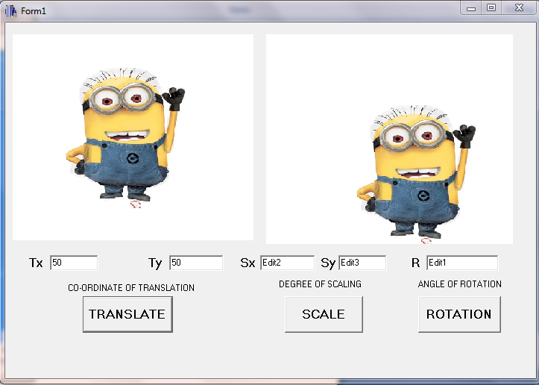

SCALING :

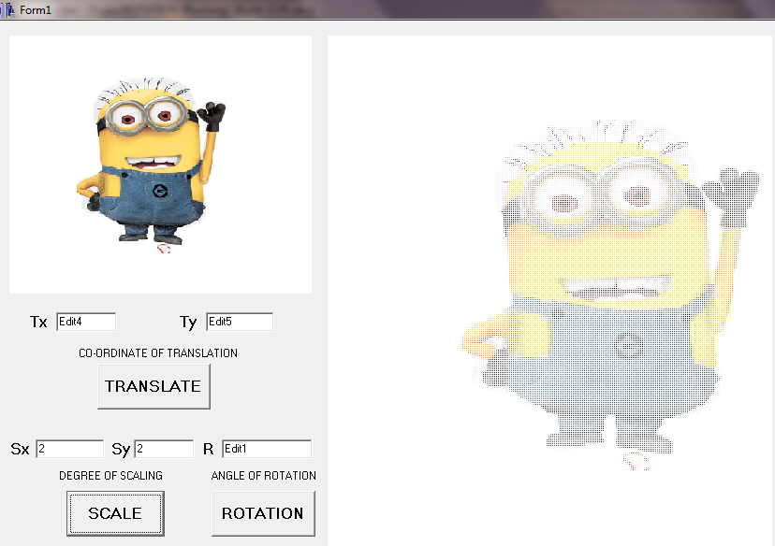

ROTATION :

